Role Profile
Job title | Employability & Enterprise Coordinator | Salary: | Up to £25,000
Reporting to: | Head of Youth Work | Holidays: | 33 days including bank holidays
Location: | Unitas Youth Zone, Burnt Oak, Barnet | Hours: | 40 hours per week (including evenings & weekends)
The Person | We are looking for someone who is passionate about supporting young people and committed to improving their future life chances through supporting them into employment destinations. This is an exciting role where you will take a lead responsibility for the delivery of Unitas Youth Zone’s Employability and Enterprise offer; ensuring all young people have access to employability and enterprise projects and the opportunity to develop their skills and knowledge, support them to be job ready and in turn to improve their future life chances. You will be adept at building and managing relationships with employers and key stakeholders to achieve our desired outcomes, as well as, naturally, being great at working with young people from all backgrounds. The post also involves the delivery of a targeted programme to support young people not currently in education, employment or training into positive destinations. If you are enthusiastic, self-motivated and driven with a keen eye for creativity and opportunity then at Unitas Youth Zone you could make a real impact.
Key Relationships: | Youth Zone staff, young people, volunteers, parents, key partners in Barnet, patrons and funders, for local employers and training providers

Application closing date: Monday 10th December 2018
Interview date: Monday 17th December 2018
Second interview date: TBC

Job Purpose:

To take a lead responsibility for the delivery of Unitas Youth Zone’s Employability & Enterprise offer, ensuring all young people have access to exciting enterprise projects and the opportunity to develop the skills and knowledge to improve their employability. The post also involves the delivery of a targeted programme to support young people not currently in education, employment or training into positive destinations.
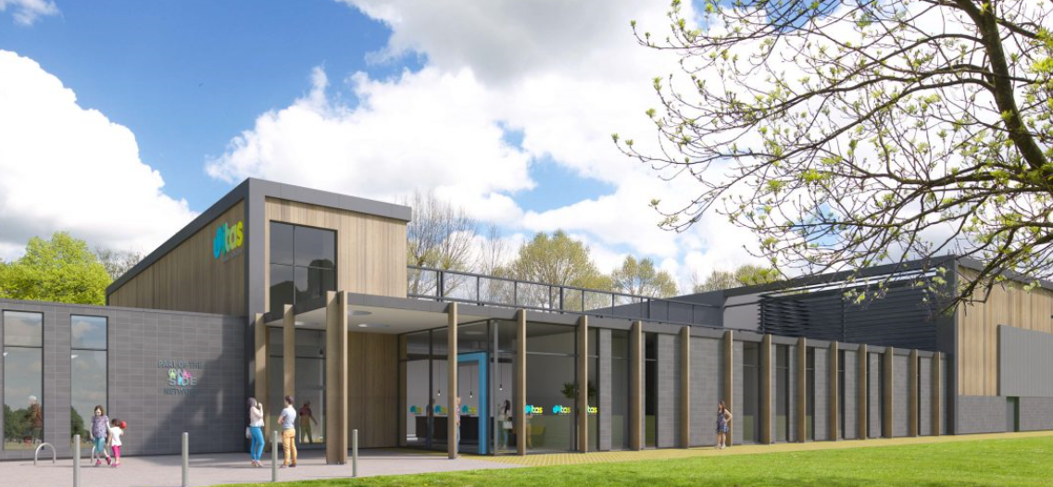

Context of the post:

Barnet Youth Zone, named “Unitas” by local young people will be one of the first Youth Zones in London opened by the national charity, OnSide in Spring 2019. This is an exciting and unique opportunity to join the delivery team pre-opening and play your part in history, shaping opportunities and Youth Work for London’s young people.

Unitas, like all OnSide Youth Zone exists to give all give young people, particularly those who are disadvantaged, somewhere to go, something to do and someone to talk to. Each Youth Zone is, open 7 days a week, at weekends and during school holidays, the Youth Zone’s purpose is to help young people grow to be happy, healthy and successful adults.

Unitas’ state-of-the-art £6.5 million building on Montrose Park, Burnt Oak, will provide young people with access to a range of activities, all offering young people the opportunity to try new things, meet new friends and gain support from friendly, warm and positive staff and volunteers. The facilities include a 3G pitch, a gym, sports hall and recreation area, and dance, arts, music and media suites seven days a week, with state-of-the-art facilities equipped for a wide range of sporting, artistic, cultural and general recreational activities and targeted services. To access a Youth Zone young people aged 8 – 19 (or 25 with additional needs), simply pay 50p per visit and £5 per year membership.

Find out more by watching ….

https://www.youtube.com/watch?v=pSJoVlndYSw

https://www.youtube.com/watch?v=Yb18h1TPRNE

https://www.youtube.com/watch?v=sZCMoDYEfTQ

……it might just change your life!
OnSide Youth Zone Network:

OnSide Youth Zones, established in 2008, has been growing rapidly and has ambitious plans to create 100 Youth Zones in towns and cities, giving young people somewhere safe and inspiring to go in their leisure time. Youth Zones are amazing places: accessible, vibrant, welcoming, fun and caring are just some of the words used by young people to describe their Youth Zone. Unitas, which is opening in Spring 2019, will be no exception, and is part of the OnSide network of Youth Zones. Youth Zones are for young people aged 8 to 19, and up to 25 for young people with additional needs.
Many young people, particularly those from socio-economically deprived areas, face an endless maze of boredom, loneliness and temptation, with nowhere to go and a lack of inspiring and productive activities to occupy their leisure time. This can lead to negative impacts on their health, educational attainment and career prospects. These are the young people that will shape the country’s future prospects. It is this paradox that lies at the heart of OnSide’s drive to establish a national network of Youth Zones; a proven model of youth service provision that is aligned to community needs and supported by cross-sector funding. Youth Zones give 8-19 year olds, and up to 25 for those with a disability, affordable access to a broad range of sport, arts and employability services, designed to help them lead active, positive lives and raise their aspirations for themselves and their community.
Duties and Responsibilities - General
- Be a role model for young people and present a positive “can do” attitude
- Take personal responsibility for own actions
- Commit to a culture of continuous improvement
- Work within the performance framework of Unitas Youth Zone and OnSide
- Represent Unitas Youth Zone positively and effectively in all dealings with internal colleagues and external partners
- Comply with all policies and procedures, with particular reference to safeguarding, codes of conduct, health and safety, equality and diversity, to ensure all activities are accessible
- Represent Unitas Youth Zone positively and effectively in all dealings with internal colleagues and external partners
- To be alert to issues of safeguarding and child protection, ensuring the welfare and safety of Youth Zone members is promoted and safeguarded. To report any child protection concerns to the designated Child Protection Officers using the safeguarding policies, procedures and practice (training to be provided)
- To assist with any promotional activities and visits that take place at Unitas Youth Zone
- To actively promote the Youth Zone and positively contribute towards increasing Unitas Youth Zone membership
Duties and Responsibilities - Detailed
- To lead on the development, delivery and review of the of the Youth Zone’s employability programme and offer by:
  - The creation and delivery of a short, targeted employability programme, which not only support NEET young people into positive destinations, but works with young people to develop in areas such as self-confidence, communication and team work
  - The creation and delivery of a job club as part of Unitas Youth Zones’ core offer
  - Establishing and maintaining strong links with partner agencies, training providers and employers
  - Ensuring young people have access to information, advice and guidance relating to access to training and employability
  - Ensuring young people have access to up to date training and employment opportunities, resources and guidance by maintaining a well-resourced enterprise zone
- To lead on the development, delivery and review of Unitas Youth Zone’s Enterprise programme and offer, working closely with the Senior and Junior Club leads to ensure enterprise projects take place and contribute towards the core Youth Zone offer
- Carry out regular review and evaluation of the enterprise and employability offer, including capturing the outcomes and positive impacts, recording soft and hard outcomes, presenting case studies and celebrating the achievements of young people
- To achieve KPI’s set by the Board, Chief Executive, Youth Work Manager and external funders, including for example, progression into employment and training or the development of employability skills
- To link into national and local initiatives such as Young Chamber and Young Enterprise, making these available to Unitas Youth Zone members and creating more opportunities for young people
- To deliver accreditation to young people, including taking responsibility for related administration
- To manage, train, support and develop part time youth workers and volunteers to contribute to the programme enterprise and employability programme
- To motivate, encourage and support young people to participate fully in sessions
- To manage the enterprise and employability budget and other resources effectively to maximise the benefits to young people
- To work with the Youth Zone staff to identify opportunities and funding for additional experiences and openings for young people relating to enterprise and employability
- To develop effective joint working with schools and other agencies to ensure a holistic approach in service delivery to young people, including representing Future Youth Zone at meetings with partner agencies
- As required, to deputise for the Youth Work Team Leaders and lead sessions, including taking responsibility for the close down and opening up of Future Youth Zone
- To support sessions across the whole Unitas Youth Zone offer as required, which takes place every evening, weekend and during school holidays and will occasionally include residential work
- Carry out any other reasonable duties as requested by management

Application Process
To apply for this position, download an application form from our website and email a completed form back to Debbie.wright@onsideyouthzones.org

The strength of the OnSide Network is the diversity of its people; we place huge value on different people doing things in different ways and we welcome applications from what might be considered non-traditional backgrounds. The one thing we all have in common is our desire to raise the aspirations of young people across the country.

Unitas Youth Zone are committed to safeguarding and promoting the welfare of children, young people and vulnerable groups; this post is subject to an enhanced DBS check.

For information regarding how OnSide Youth Zones processes your data, please click here: https://www.onsideyouthzones.org/applicant-privacy/

Key Words

Employability Manager; Youth Development Manager; Careers and Enterprise; Youth Opportunities Coordinator; NEET; Support Worker, Youth Progression; Employability

Person Specification

Selection Criteria*  A = Application Form I = Interview T = Test/Personality Profile |  | Selection Criteria* | Selection Criteria*
Experience
Proven experience of working with young people aged 8 to 19 (25 with disabilities) in a range of settings |  | Essential | A & I
Proven experience of engaging vulnerable, disengaged or hard to reach young people |  | Essential | A & I
Experience working in a team and with volunteers |  | Essential | A & I
Experience of youth work and delivering youth work programmes |  | Essential | A & I
Experience of delivering enterprise and employability programmes and workshops to young people |  | Essential | A & I
Experience supporting NEET 16-21 year olds into positive destinations |  | Essential | A & I
Experience of monitoring and evaluation processes |  | Desirable | A & I
Experience of work with those with disabilities and additional needs |  | Desirable | A & I
Experience managing externally funded projects |  | Desirable | A & I
Experience providing information, advice, guidance and support to young people |  | Desirable | A & I
Experience of dealing with safeguarding issues within a multi-agency setting |  | Desirable | A & I
Experience of running own business |  | Desirable | A
Experience working in the commercial sector (for example retail or service) |  | Desirable | A
Skills
Excellent written and verbal communication |  | Essential | A & I
Ability to coach, encourage, motivate and provide reliable support to children and young people |  | Essential | A & I
Ability to work with groups of young people |  | Essential | A & I
Strong commitment to young people and ability to engage and build positive relationships with disengaged young people |  | Essential | A & I
Ability to establish good professional relationships with young people, adults and partner agencies/organisations |  | Essential | A & I
Ability to manage and organise several tasks at a time |  | Essential | A & I
Ability to take initiative and work creativity |  | Essential | A & I
IT literate |  | Essential | A & I
Knowledge
Knowledge of the issues affecting young people |  | Essential | A & I
Understanding of the principles of working with children and young people |  | Essential | A & I
Knowledge of recruitment and selection process |  | Desirable | A & I
Knowledge of health and safety, diversity awareness and safeguarding best practice and how these relate to children and young people |  | Desirable | A & I
Educational / Vocational Qualifications
A professional qualification at level 4 or above |  | Essential | A
GCSE or equivalent literacy and numeracy |  | Essential | A
A professional youth work or teaching qualification at level 4 or above (or equivalent) |  | Desirable | A
Special Requirements
A willingness to work unsociable hours when required |  | Essential | A & I
DBS clearance and committed to Safeguarding children |  | Essential | A & I
The ability and willingness to travel to meetings and events both in the region and beyond |  | Essential | A & I

*Selection criteria for guidance only, alternative methods may be used to assist the selection process

OnSide Youth Zones Values

