Role Profile

Job title | Inclusion Coordinator | Salary: | Circa £25,000
Reports to: | Head of Youth Work | Holidays: | 33 days including bank holidays
Location: | Unitas Youth Zone  Burnt Oak, Barnet | Hours: | 40 hours per week (including evenings & weekends
The Person: | Do you want to use your skills as an inclusion Youth Worker to positivity change the lives of young people in Barnet? Can you encourage community cohesion and provide an environment where members from diverse demographics, ethnic communities who have mild to moderate special educational needs with disabilities feel safe and can thrive? Are you committed to equality?
Key  Relationships: | Chief Executive, Fundraising Development Manager, Head of Youth  Work, Volunteer & Training Manager, Other Youth Zone staff,  Onside, External Stakeholders, Young People, Parents.
Key Dates: | Closing date for application: 12pm 18th February 2019  First interview: Venue: Barnet. Date: To be confirmed  Second interview: Venue: Must be prepared to travel to one of our established Youth Zones in the North West (within a couple of weeks of the first interview)
Job purpose
We are looking for somebody who wants to ensure Unitas Youth provision is inclusive, supports community cohesion and provides an environment where members from diverse demographics, ethnic communities, and those with disabilities feel safe, involved and welcome. To broaden and increase overall participation rates to ensure participation is representative of the demographics of Barnet. Carry out targeted outreach and partnership work across the region to promote Unitas Youth Zone and gain an understanding of the barriers to participation and work to overcome these. Most importantly, ensure all young people are welcome and feel able to participate in all activities, no matter who they are. #youngpeoplecan

Context of the post:
OnSide Youth Zones, established in 2008, has been growing rapidly and has ambitious plans to create 100 Youth Zones in towns and cities, giving young people somewhere safe and inspiring to go in their leisure time. Youth Zones are amazing places: accessible, vibrant, welcoming, fun and caring are just some of the words used by young people to describe their Youth Zone. Unitas, opening in Summer 2019, will be no exception, and is part of the OnSide network of Youth Zones.
Many young people, particularly those from socio-economically deprived areas, face an endless maze of boredom, loneliness and temptation, with nowhere to go and a lack of inspiring and productive activities to occupy their leisure time. This can lead to negative impacts on their health, educational attainment and career prospects. These are the young people that will shape the country’s future prospects. It is this paradox that lies at the heart of OnSide’s drive to establish a national network of Youth Zones; a proven model of youth service provision that is aligned to community needs and supported by cross-sector funding. Youth Zones give young people affordable access to a broad range of sport, arts and employability services, designed to help them lead active, positive lives and raise their aspirations for themselves and their community.

Unitas Youth Zone is centrally located, dedicated to young people and makes a bold statement about the importance of giving young people high quality places to go in their leisure time. Open 7 days a week including school holidays, the Youth Zone’s purpose is to help young people grow to be happy, healthy and successful adults. The state-of-the-art £6.5 million building will provide young people with access to a range of activities, all offering young people the opportunity to try new things, meet new friends and gain support from friendly, warm and positive staff and volunteers. The facilities include a 3G pitch, a gym, sports hall and recreation area, and dance, arts, music and media suites.

Find out more by watching ….

https://www.youtube.com/watch?v=Yb18h1TPRNE

https://www.youtube.com/watch?v=sZCMoDYEfTQ
……it might just change your life!

Duties and Responsibilities General
- Be a role model for young people and present a positive “can do” attitude
- Commit to a culture of continuous improvement
- Work within the performance framework of Unitas Youth Zone and OnSide
- Represent Unitas Youth Zone positively and effectively in all dealings with internal colleagues, and external partners
- Comply with all policies and procedures, with special attention to safeguarding, codes of conduct, health and safety and equality ensure activities are accessible

Duties and Responsibilities – Detailed
- Identify the diverse needs of young people within the Barnet youth zone delivery plan,
- Coordinate and deliver youth work targeting members with additional needs ensuring they benefit from participation and have a sense of belonging.
- Work with part time youth workers, volunteers, parents of young people and community representatives to prepare and deliver youth development activities and undertake outreach work to promote the Youth Zone’s provision across all communities ensuing an inclusive approach is adopted across the programme and facility.
- Support young people’s involvement, helping them to have a voice and become young leaders for their communities, supporting and encouraging them to play a more active role in civic life.
- Understand the community issues around young people with special educational needs and disabilities. To build trust with young people their families and SEND support networks and partners in order to build stronger community cohesion and inclusion.
- Positively Influence the general programme of events at the Youth Zone so that it is attractive to young people from diverse backgrounds and abilities across a 7-day week
- Contribute to the building of effective partnerships with statutory and voluntary services and other relevant agencies
- Organise, participate in and evaluate outreach events that bring together the different communities including support for marketing activities for such events across the City
- To ensure access to volunteering opportunities are available to young people in particular SEND
- Manage the allocated budget for outreach work and other resources effectively and efficiently
- Carry out any other reasonable duties as requested by the head of youth work and or SLT
Application Process
To apply for this post and for further information about Unitas Youth Zone please visit our website at
https://www.unitasyouthzone.org/get-involved/vacancies/ and complete the application form.
In accordance with our Child Protection and Safeguarding procedures, this position requires an Enhanced DBS check

Key Words
Inclusion worker, youth work, SENCO, Youth club lead, youth coordinator, lead youth worker, youth support worker, children’s and young people worker, youth development worker, youth programme manager. Outreach worker, young people in care, Special educational needs and disabilities.

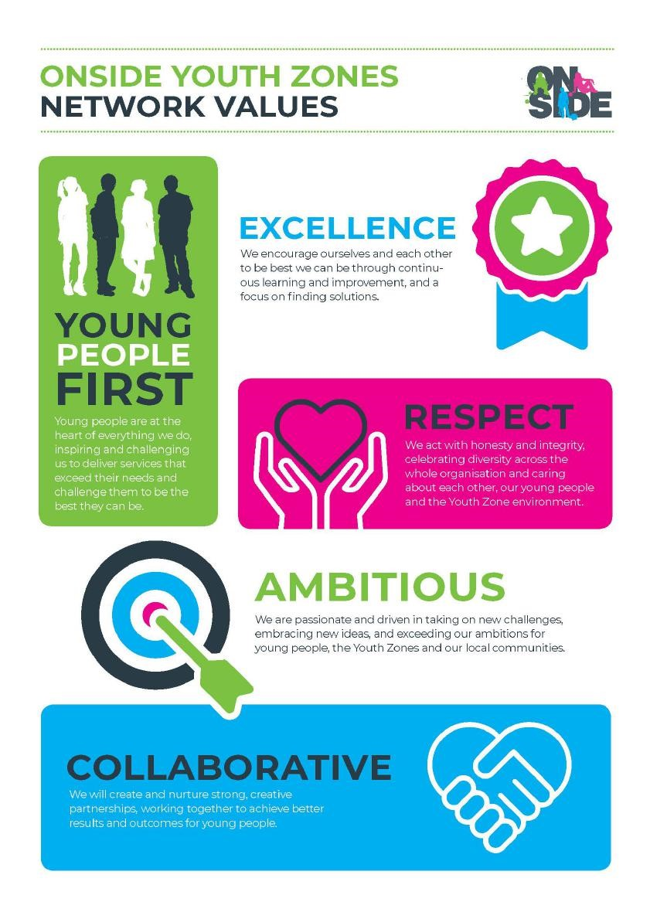
Onside Youth Zones Values

