Role Profile
Job title | Youth Club & Holiday Club Manager for 8 -12 year olds | Salary: | Circa £28,000
Reporting to: | Head of Youth Work | Holidays: | 33 days including bank holidays
Location: | Unitas Youth Zone (Burnt Oak, Barnet) | Hours: | 40 hours per week (including evenings & weekends)
The Person: | We are looking for someone who is passionate about Youth Work and Play Work and wants to see the lives of 8-12 year olds transformed through access to an exciting, fun and engaging Junior and Holiday Club Programme. You will be comfortable managing and leading a team in the design, delivery and continuous improvement of our Junior sessions.
Key Relationships: | Youth Zone staff, young people, volunteers, parents, key partners in Unitas Youth Zone.

Job Purpose
You will have the lead responsibility for the Junior and Holiday Club offer for
8-12-year olds, however, as a Youth Zone Manager, you will be expected to work across all Unitas Youth Zone sessions. You will ensure the delivery of a high-quality, creative and fun offer focusing on the needs of young people in line with Unitas Youth Zone’s aspirations, to provide young people with the best possible experiences and opportunities. You will have a passion for putting young people first!

Holiday Club runs all day Monday to Friday during school holidays. You will be responsible for the continuous improvement of the delivery and contribute towards the strategic delivery plan for Unitas Youth Zone.

This is a fun, exciting and challenging role in a new, growing and ambitious charity where, with up to 250 young people attending a session, no two days will be the same.

Context of the post:
OnSide Youth Zones, established in 2008, has been growing rapidly and has ambitious plans to create 100 Youth Zones in towns and cities, giving young people somewhere safe and inspiring to go in their leisure time. Youth Zones are amazing places: accessible, vibrant, welcoming, fun and caring are just some of the words used by young people to describe their Youth Zone. Unitas, opening in Summer 2019, will be no exception, and is part of the OnSide network of Youth Zones.
Many young people, particularly those from socio-economically deprived areas, face an endless maze of boredom, loneliness and temptation, with nowhere to go and a lack of inspiring and productive activities to occupy their leisure time. This can lead to negative impacts on their health, educational attainment and career prospects. These are the young people that will shape the country’s future prospects. It is this paradox that lies at the heart of OnSide’s drive to establish a national network of Youth Zones; a proven model of youth service provision that is aligned to community needs and supported by cross-sector funding. Youth Zones give young people affordable access to a broad range of sport, arts and employability services, designed to help them lead active, positive lives and raise their aspirations for themselves and their community.

Unitas Youth Zone is centrally located, dedicated to young people and makes a bold statement about the importance of giving young people high quality places to go in their leisure time. Open 7 days a week including school holidays, the Youth Zone’s purpose is to help young people grow to be happy, healthy and successful adults. The state-of-the-art £6.5 million building will provide young people with access to a range of activities, all offering young people the opportunity to try new things, meet new friends and gain support from friendly, warm and positive staff and volunteers. The facilities include a 3G pitch, a gym, sports hall and recreation area, and dance, arts, music and media suites.

Find out more by watching ….

https://www.youtube.com/watch?v=Yb18h1TPRNE

https://www.youtube.com/watch?v=sZCMoDYEfTQ
……it might just change your life!

Duties and Responsibilities - General
- Be a role model for young people and present a positive “can do” attitude
- Take personal responsibility for own actions
- Commit to a culture of continuous improvement
- Work within the performance framework of Unitas Youth Zone and OnSide
- Represent Unitas Youth Zone positively and effectively in all dealings with internal colleagues, and external partners
- Comply with policies and procedures, with reference particular to safeguarding, codes of conduct health and safety and equality ensuring all activities are accessible
- Represent Unitas Youth Zone positively and effectively in all dealings with internal colleagues, and external partners
- To be alert to issues of safeguarding and child protection, ensuring the welfare and safety of Youth Zone members is promoted and safeguarded reporting any child protection concerns to the designated Child Protection Officer/s using safeguarding policies, procedures and practice (training to be provided)
- To assist with any promotional activities and visits that take place at the Youth Zone
- To actively promote the Youth Zone and positively contribute towards increasing Youth Zone membership
- To adhere to Unitas Youth Zone policies at all times, with particular reference to Health and Safety, Safeguarding and Equal Opportunities
Duties and Responsibilities - Detailed
- To lead on the development, implementation and review of the Junior and Holiday Club offer by:
Coordinating input from and ownership from the wider staff team and young people including the sports, arts, inclusion and enterprise coordinators, to provide a diverse offer which responds to the needs and interests of young people.
To ensure that there is a clear path in place for young people to transition from the Junior Club to the Senior Club; working closely with the Senior Club Manager to achieve this.
Ensure the Junior programme is safe, creative, fun, challenging and contributes toward the development and growth of young people, in particular self-esteem and confidence, social skills, resilience, health and aspiration.
Ensure the programme is varied in nature, making full use of the Youth Zones facilities and the diverse skill set of the staff team ensuring the offer includes the arts, sports, issue-based work, enterprise, support advice and guidance and much more
Ensure regular review and evaluation of the programme including: capturing the outcomes and positive impacts, recording soft and hard outcomes, presenting case studies and celebrating the achievements of young people
Ensuring high reach and engagement across the Junior and Holiday club, achieving and exceeding KPI’s set by the Board, Chief Executive and Head of Youth Work including for example membership, attendance and representation.
- To lead the delivery team on sessions providing:
Clear hands on leadership, role modelling and coaching to ensure high standards of delivery are maintained

Clear structure, planning and purpose to underpin every session with clear session briefs and debriefs

Leading on safeguarding and behaviour management during sessions to ensure Unitas Youth zone is a welcoming environment for all young people

To ensure compliance with safe working practices to ensure the safety of young people
- To manage, induct, train, support and develop a team of full and part time youth workers and volunteers to contribute to the programme development and delivery working with the Training and Volunteer Manager supporting CPD and opportunities for accredited and recorded learning
- To motivate, encourage and support young people to participate fully in sessions
- To oversee the Junior and Holiday Club budget and other resources effectively to maximise the benefits to young people
- To support the Youth Zone promotional and outreach plan working in the community both with partners and directly with young people
- To work with the Youth Zone staff to identify opportunities and funding for additional opportunities and experiences for young people
- To take a lead role in ensuring the safeguarding of young people by
Ensuring understanding and implementation of all the roles and responsibilities in relation to Safeguarding Children and Young People

Ensuring staff and volunteers maintain safeguarding standards and contribute toward safeguarding strategy at Unitas Youth Zone, in particular safeguarding issues and themes facing young people are raised and addressed

Attending and contributing towards safeguarding meetings and strategies procedures involving young people you are working with.

- To develop effective joint working with schools and other agencies to ensure a holistic delivery approach to young people including representing the Youth Zone at meetings with partner agencies
- To, as a key holder take responsibility for the opening set up delivery and closing of the youth zone as required.
- To support across the Youth Zone offer as required: ( 7 days per week including , weekends, during school holidays and residential work sessions)
- To deputise for the Head of Youth Work as required
- Carry out any other reasonable duties as requested by management

Application Process
To apply for this post and for further information about Unitas Youth Zone please visit our website at
https://www.unitasyouthzone.org/get-involved/vacancies/ and complete the application form.

This position requires an Enhanced DBS check In accordance with Child Protection and Safeguarding procedures,

Key Words
Senior youth worker, youth work lead, youth work manager, youth club lead, youth club coordinator, play worker, Junior youth worker, lead youth worker, youth support worker, children’s and young people worker, child development worker.

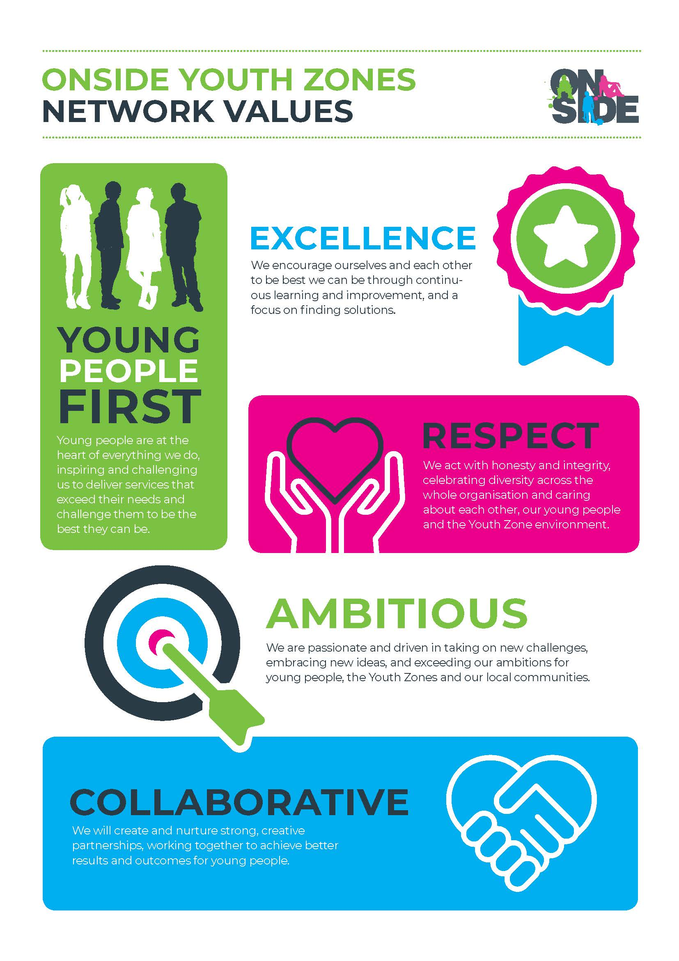
OnSide Youth Zones Values

