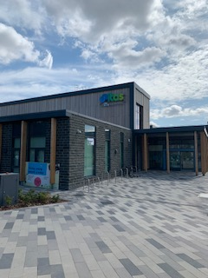

INCLUSION HANDBOOK

WELCOME!

The team at Unitas Youth Zone would like to give you a very warm welcome to our amazing youth centre. Here at Unitas we pride ourselves on being inclusive and that is why we will go the extra mile to ensure any young person with a special educational need or disability (SEND) can become a member and experience the activities that we have on offer.

This handbook will provide you with some additional information about how we handle Inclusion at Unitas and what we have in place to support you/ your young person on their journey with us here.

Your main point of contact will be our Inclusion Coordinator (Ashani Hailstones-Lee) who will be available to answer any questions, provide any support and maintain regular communication to ensure you/young person are getting the best out of Unitas. If Ashani is unavailable to speak to you temporarily, any member of the management or inclusion team will be able to provide some support and assistance.

What we have to offer
We provide 7 days a week universal youth provision from 4 pm, and of a weekend, for young people aged 8 to 19 (or up to 25 with disability or additional needs). They will have access to a minimum of 20 activities every session including a sports hall, music room and recording studio, gym, climbing wall, rooftop football pitch, a café, arts room, performing arts room, media room, boxing ring, learning kitchen and much, much more - all for just 50 p per visit and £5 annual membership. We also have a food hot offer (£1) and a tuck shop where young people can purchase various snacks.
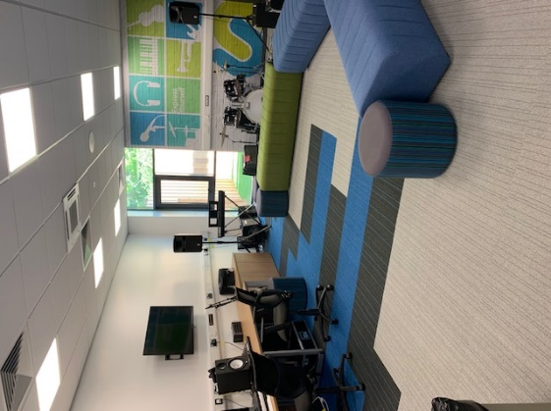
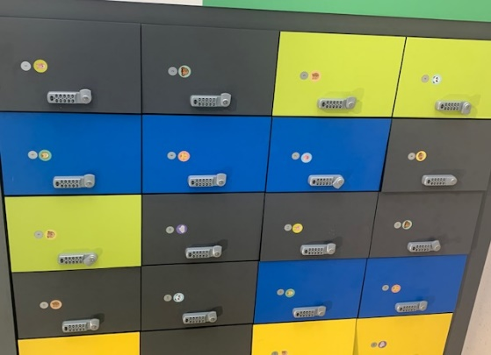
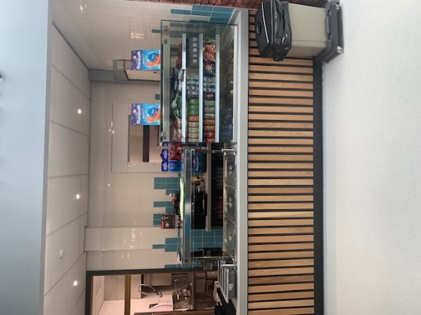
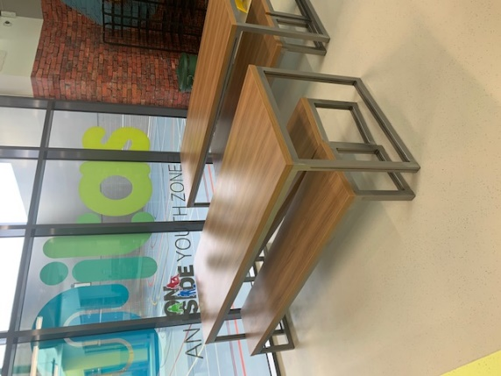
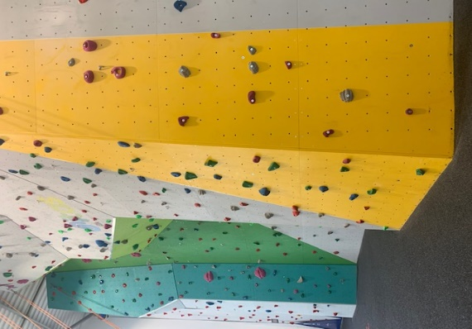
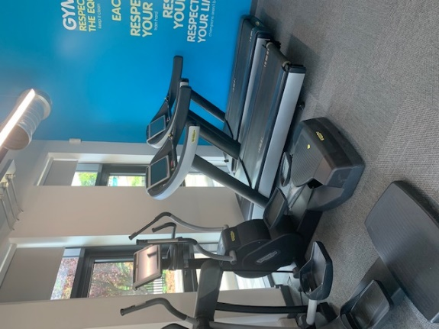

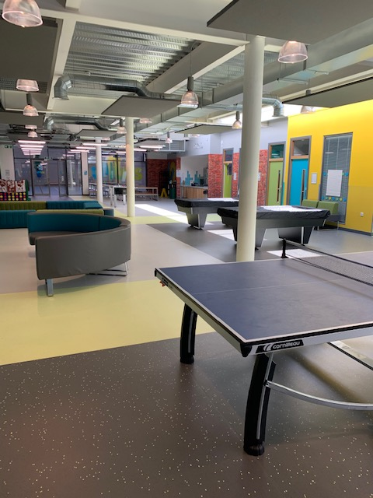
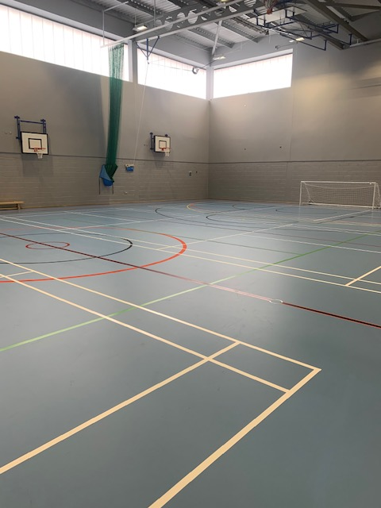
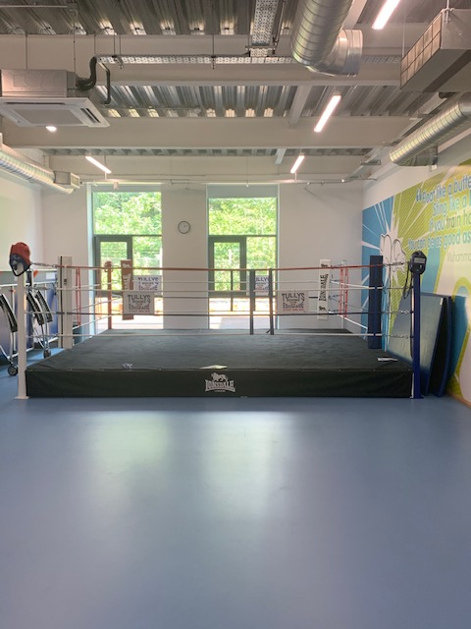
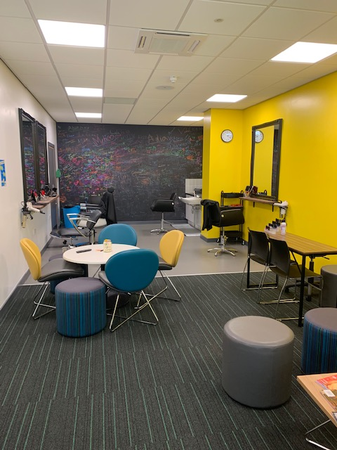
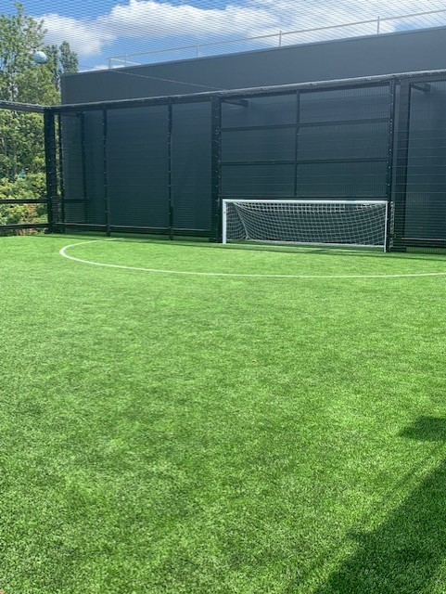
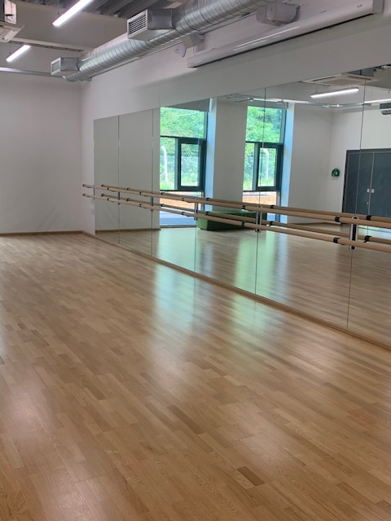
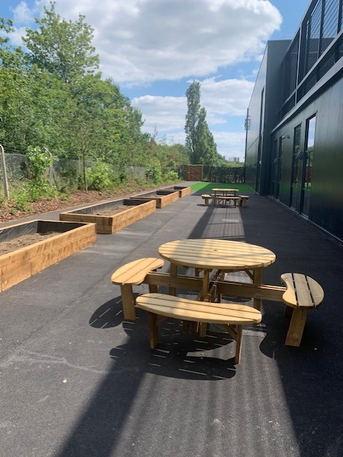
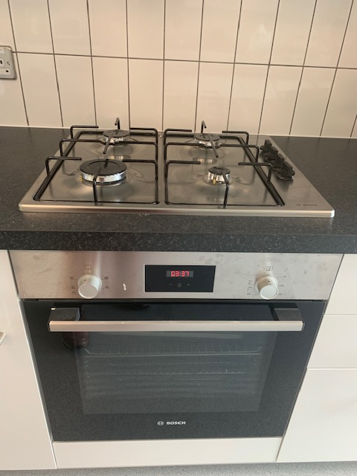
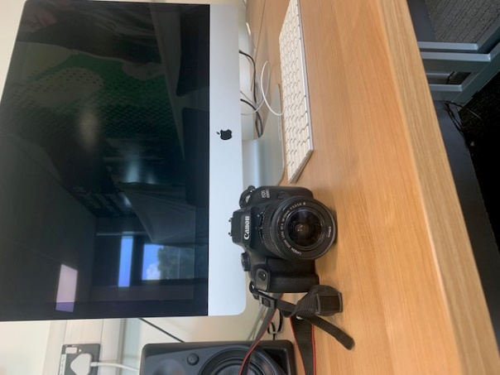

Limitless- Our Inclusion session

We run an inclusion every Sunday from 10 am-2 pm with a hot food offer at just £1; this session is attended specifically by young people with disabilities and additional needs. They may be accompanied by their parents/carers/support workers or their siblings. You are welcome to leave young people during this session who do not require one to one support, on the understanding that parents and carers/support workers are in attendance who are not directly employed by Unitas Youth Zone. DBS checks may not have been carried out for parents who attend this particular session.
All our activities on this session are adapted for young people with additional needs; the session is much more relaxed than the other sessions throughout the week and has more of a family-oriented vibe. It is highly recommended as a session for those who are attending for the first time.

Please note: This is the ONLY session where we allow parents to come into a session, we do not allow it on any other session.

Our Sensory Room

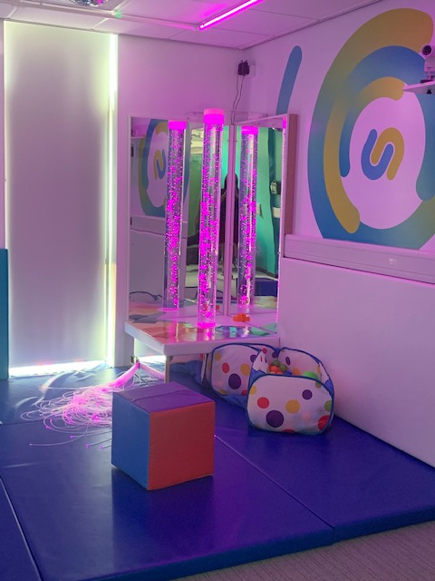

We have a sensory room onsite for young people who need a quiet space during a session. In this room we have sensory toys, interactive floor games, fibre optic tails, a hidey hut, a bubble tower and various lighting settings for sensory stimulation.

Tours/ One to one meetings/ Inductions

All young people who declare a disability or additional needs are offered the chance of a one to one induction with the inclusion team to ensure any additional support needs are met. If this is something you would like to take up or if you have any further questions or concerns, please speak to a member of the inclusion team on session or contact Ashani.

If you would like to book a tour or a one to one meeting with Ashani to discuss any further needs or support, this can be arranged via email.

Please note: Tours cannot take place during our session time as we will have high numbers of young people in the building during operating hours.

Young people who require 1-2-1 support
Unitas is not able to provide one to one support/personal care for young people. To help remove this barrier, young people who require one to one support are welcomed to provide this themselves via a Support Worker/direct payment worker, by arrangement via Ashani (Inclusion Coordinator).

Please note: It is the responsibility of the parent/carer to source and provide this 1-2-1 support for the young person.

However, to attend junior and senior sessions with support, we MUST have carried out a DBS check for any support worker/carer prior to entry. This can be arranged with Ashani prior to the young person attending the session.

Anything regarding a young person needing to take medication whilst on session at Unitas MUST be discussed with Ashani prior to attending the youth zone.
Please note: Young people are not permitted to take medication onsite without supervision.
Other facilities
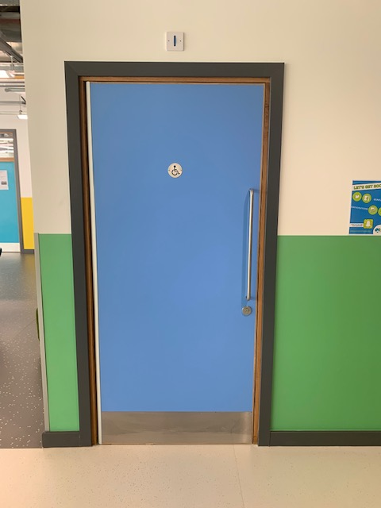

We have 2 disabled access toilets

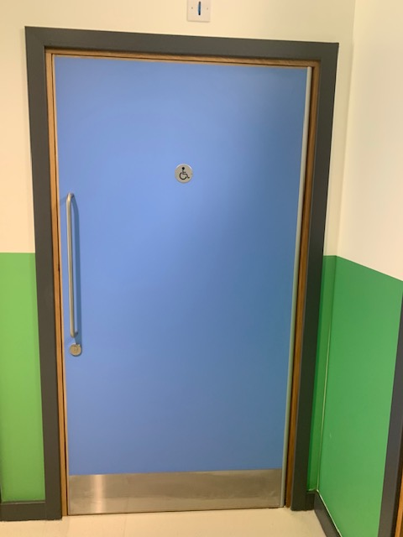
Disabled access changing toilets (this will only be operated by a young person’s carer, not the Unitas staff)

Lift access to the MUGA football pitch

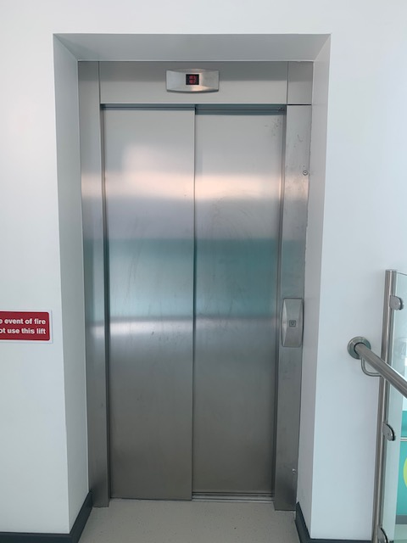

Contact Details

If you have any further enquiries; please contact the email address below:

Inclusion Coordinator (SEND): Ashani Hailstones-Lee
Email: ashani.hailstones-lee@unitasyouthzone.org

Other contact details:

Head of Youth Work: Kyle Blackwood
Email: Kyle.Blackwood@unitasyouthzone.org

Chief Executive: Tony Lewis
Email: tony.lewis@unitasyouthzone.org

Senior Lead: Alexia Lee
Email: alexia.lee@unitasyouthzone.org

Junior Lead: Chloe Greenberg
Email: chloe.greenberg@unitasyouthzone.org

