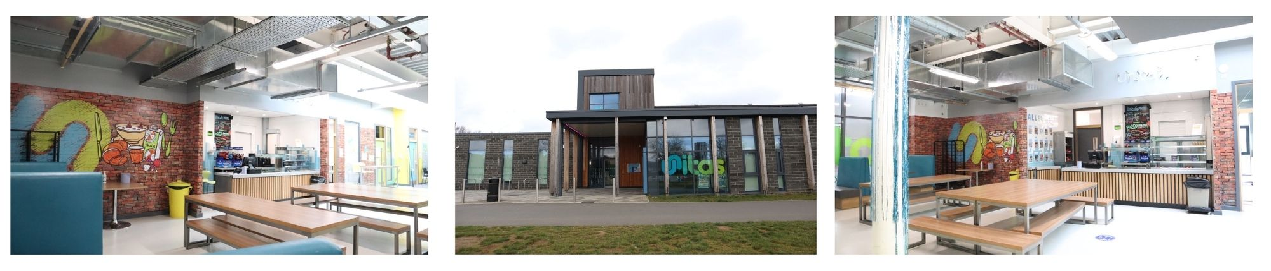

**Location: Unitas Youth Zone, Edgware**

**Suggested Time Commitment: 1 session per week (although there is flexibility in this)**

**CATERING AND TUCK SHOP VOLUNTEER**

* Enjoys meeting and engaging with people from a wide range of backgrounds
* Is patient and has the ability to able to confidently manage multiple tasks in a busy kitchen environment
* Has a level 2 qualification in food safety but, if you don’t, a willingness to partake in the course (paid for by Unitas) will be more than enough!
* Shares the same values as Unitas
* Is committed to making a positive impact on the lives of young people   
  ------------------------------------------------------------------------------------------------------------------------------------------------------

**Please note that for this role you need to be at least 18 years of age and be prepared to undergo an enhanced DBS check.**

**WE’RE LOOKING FOR SOMEONE WHO:**

You will gain new skills and develop existing ones whilst making a significant contribution to the lives of the young people. You will become part of our team and our young people will have a great time. You will enhance your CV whilst also being there as a positive role model to many of our young people. The benefits really are endless!

**WHAT ARE THE BENEFITS TO YOU AND OUR YOUNG PEOPLE?**

* Prepping food for the young people on session
* Serving young people at the counter or tuck shop
* Helping to maintain cleanliness and organisation within the kitchen and counter areas
* Using the till and cash handling
* Maintaining health and safety standards
* Customer service and relationship building with young people across the youth zone
* Working collaboratively with members of staff to support the delivery of sessions
* Acting as a positive role model for young people
* Promoting an inclusive culture where all young people are listened to, valued, and cared for

**WHAT CAN YOU EXPECT TO BE DOING?**

Our Catering and Tuck Shop Volunteers help us to provide young people with a hearty, affordable meal for only £1. They’re the friendly faces who support the smooth running of sessions by making sure bellies are full and minds are engaged. This allows us to run sessions for young people that build their confidence, social skills and overall wellbeing.

**ABOUT THE ROLE**