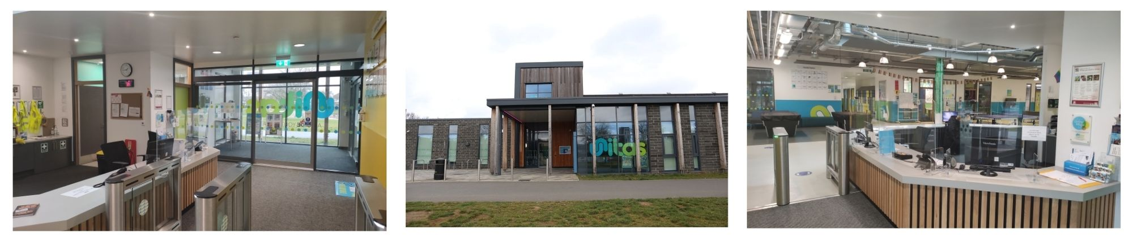

* Acting as the first point of contact for Young People coming into the Youth Zone
* Helping with administrative tasks such as; admission for members, giving tours and answering queries
* Helping to maintain cleanliness and organisation within the reception area
* Handling telephone and email enquiries
* Ensuring new members are welcomed in and introduced to the appropriate member of staff
* Building positive relationships with young people across the youth zone
* Working collaboratively with the reception team and other members of staff to support the delivery of sessions
* Acting as a positive role model for young people
* Promoting an inclusive culture where all young people are listened to, valued, and cared for

**Location: Unitas Youth Zone, Edgware**

**Suggested Time Commitment: 1 session per week (although there is flexibility in this)**

**RECEPTION AND ADMINISTRATION VOLUNTEER**

* Enjoys meeting and engaging with people from a wide range of backgrounds
* Is organised and efficient
* Some customer service and administration experience would be great but, if you don’t have any, a willingness to learn will be more than enough!
* Basic IT skills
* Shares the same values as Unitas
* Is committed to making a positive impact on the lives of young people   
  ------------------------------------------------------------------------------------------------------------------------------------------------------

**Please note that for this role you need to be at least 18 years of age and be prepared to undergo an enhanced DBS check.**

**WE’RE LOOKING FOR SOMEONE WHO:**

You will gain new skills and develop existing ones whilst making a significant contribution to the lives of the young people. You will become part of our team and our young people will have a great time. You will enhance your CV whilst also being there as a positive role model to many of our young people. The benefits really are endless!

**WHAT ARE THE BENEFITS TO YOU AND OUR YOUNG PEOPLE?**

**WHAT CAN YOU EXPECT TO BE DOING?**

Our Reception and Administration Volunteers are the face of our Youth Zone. They welcome in young people with a smiling face and a warm ‘hello’. In addition to this, they provide us with vital administrative support that allows us to run sessions for young people that build their confidence, social skills and overall wellbeing.

**ABOUT THE ROLE**