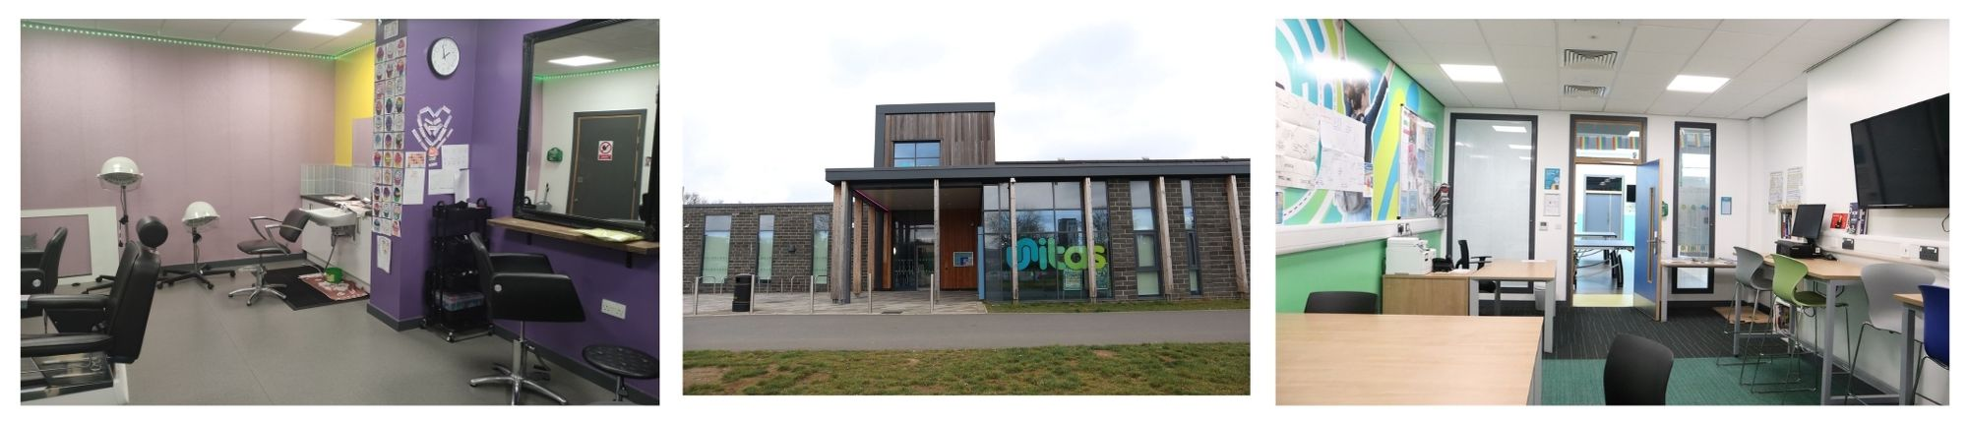

**Location: Unitas Youth Zone, Edgware**

**Suggested Time Commitment: 1 session per week (although there is flexibility in this)**

**SPECIALIST SKILL VOLUNTEER**

* Enjoys meeting and engaging with people from a wide range of background
* Is patient and has the ability to confidently manage the task at hand in a busy environment
* Shares the same values as Unitas
* Is committed to making a positive impact on the lives of young people   
  ------------------------------------------------------------------------------------------------------------------------------------------------------

**Please note that for this role you need to be at least 18 years of age and be prepared to undergo an enhanced DBS check.**

**WE’RE LOOKING FOR SOMEONE WHO:**

* We would expect you to plan your content and then liaise with session staff to get final approval
* You would need to be fully compliant with our policies and procedures
* You’ll be happy to take suggestions from youth zone staff
* You’ll promote an inclusive culture where all young people are listened to, valued, and cared for

**WHAT WOULD WE EXPECT?**

By sharing your expertise or skill you will make a significant contribution to the lives of the young people. You will become part of our team and our young people will have a great time. You will enhance your CV whilst also being there as a positive role model to many of our young people. The benefits really are endless!

**WHAT ARE THE BENEFITS TO YOU AND OUR YOUNG PEOPLE?**

Here are some examples of specialist skill volunteers we’ve had before

* Architects running workshops on what they do and how they do it
* Hairdressers ‘setting up shop’ at the youth zone to show young people what they do and styling their hair to make them feel fabulous!
* Employability specialists running coaching sessions
* Entertainers performing for our young people and giving them an insight into the world of the performance
* Gardeners running life skills projects to show our young people how to grow their own food

**WHAT KIND OF THINGS COULD I DO?**

Do you have a special skill that you think our young people would be interested in? If so, you can really make this role your own! We’re looking for volunteers who can inspire our young people to think creatively, dream big and look at the world a little differently. If this sounds like something you could do, then we want to hear from you!

**ABOUT THE ROLE**