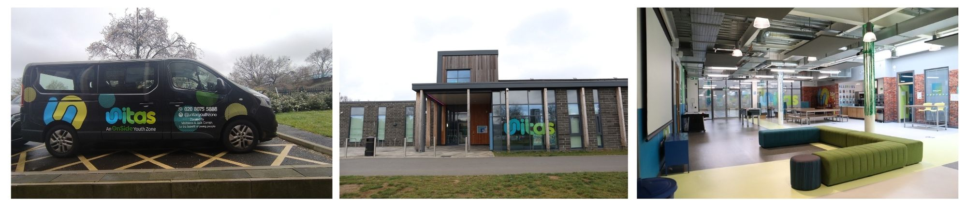

**Location: Unitas Youth Zone, Barnet**

**Suggested Time Commitment: AD HOC**

**VOLUNTEER DRIVER**

* Is older than 21, has a valid driver’s license and has held it for at least 2 years
* Enjoys meeting and engaging with people from a wide range of backgrounds
* Is comfortable lone working
* Is comfortable planning routes and following directions (using sat nav)
* Shares the same values as Unitas
* Is committed to making a positive impact on the lives of young people   
  ------------------------------------------------------------------------------------------------------------------------------------------------------

**Please note that for this role you need to be at least 18 years of age and be prepared to undergo an enhanced DBS check.**

**WE’RE LOOKING FOR SOMEONE WHO:**

You will get to interact with a wide range of people whilst providing young people with opportunities to experience new things and see new places. You will become part of our team and our young people will have a great time. You will enhance your CV whilst also being there as a positive role model to many of our young people. The benefits really are endless!

**WHAT ARE THE BENEFITS TO YOU AND OUR YOUNG PEOPLE?**

* Transporting young people and members of staff in our mini bus
* Collecting donations from partners across the community/city
* Helping to maintain cleanliness of the mini bus
* Interacting with young people
* Working collaboratively with the youth zone team to support the delivery of sessions
* Acting as a positive role model for young people
* Promoting an inclusive culture where all young people are listened to, valued, and cared for

**WHAT CAN YOU EXPECT TO BE DOING?**

Our Volunteer Drivers make it possible for us to offer exciting trips for the young people who come to our Youth Zone. In addition to this, they provide us with vital logistical support (by picking up donations from partners in the community) that allows us to run sessions for young people that build their confidence, social skills and overall wellbeing.

**ABOUT THE ROLE**