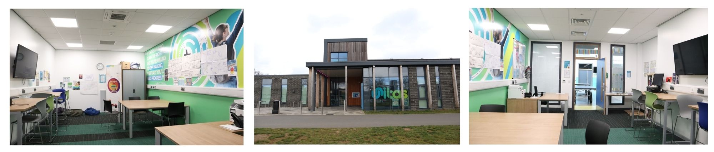

**Location: Unitas Youth Zone, Barnet**

**Suggested Time Commitment: 1 session per week (although there is flexibility in this)**

**VOLUNTEER EMPLOYABILITY YOUTH WORKER**

Our Volunteer Employability Youth Workers help us deliver employability support through our careers and enterprise provision. They support young people’s career aspirations, celebrate their skills, experience and qualities. They help us to encourage them to take opportunities both in and out of the centre, that develop their skills and characters.

**ABOUT THE ROLE**

* Enjoys meeting and engaging with people from a wide range of backgrounds
* Is adaptable and empathetic
* An active interest in careers and personal development
* Shares the same values as Unitas
* Is committed to making a positive impact on the lives of young people

Please note that for this role you need to be at least 18 years of age and be prepared to undergo an enhanced DBS check.

**WE’RE LOOKING FOR SOMEONE WHO:**

You will develop your existing skills whilst passing on your expertise and making a significant contribution to the lives of the young people. You will become part of our team and our young people will have a great time learning new skills. You will enhance your CV whilst also being there as a positive role model to many of our young people. The benefits really are endless!

**WHAT ARE THE BENEFITS TO YOU AND OUR YOUNG PEOPLE?**

* Helping to deliver specific employability support such as: CV writing, mock interviews and highlighting different career pathways
* Supporting our Careers manager to source opportunities for career encounters for our young people through actively promoting our work to your networks
* Supporting our young people with application forms (for university or work)
* Building positive relationships with young people across the youth zone
* Working collaboratively with the Employability Youth Worker and other members of staff to support the delivery of sessions
* Supporting young people with additional needs
* Acting as a positive role model for young people
* Promoting an inclusive culture where all young people are listened to, valued, and cared for

**WHAT CAN YOU EXPECT TO BE DOING?**