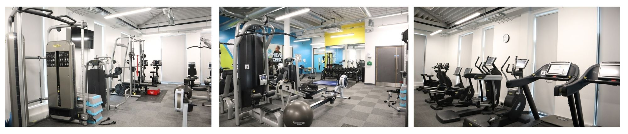

**Location: Unitas Youth Zone, Barnet**

**Suggested Time Commitment: 1 session per week (although there is flexibility in this)**

**VOLUNTEER GYM YOUTH WORKER**

* Enjoys meeting and engaging with people from a wide range of backgrounds
* Some experience in a gym setting or a personal training qualification would be preferred
* Loves working within a team and getting involved in group activities
* Enjoys being active and partaking in physical activities
* Shares the same values as Unitas
* Is committed to making a positive impact on the lives of young people

------------------------------------------------------------------------------------------------------------------------------------------------------

**Please note that for this role you need to be at least 18 years of age and be prepared to undergo an enhanced DBS check.**

**WE’RE LOOKING FOR SOMEONE WHO:**

You will gain new skills and develop existing ones whilst making a significant contribution to the lives of the young people. You will become part of our team whilst our young people will gain a positive experience of fitness and physical activity. You will enhance your CV whilst also being there as a positive role model to many of our young people. The benefits really are endless!

**WHAT ARE THE BENEFITS TO YOU AND OUR YOUNG PEOPLE?**

* Setting up equipment before sessions and packing up at the end
* Helping to deliver not only standard gym sessions, but also including fitness classes and competitions
* Motivating young people to participate and enjoy their sessions
* Building positive relationships with young people across the youth zone
* Working collaboratively with the Sports Team Leader and other members of staff to support the delivery of gym sessions
* Supporting young people with additional needs
* Acting as a positive role model for young people
* Promoting an inclusive culture where all young people are listened to, valued, and cared for

**WHAT CAN YOU EXPECT TO BE DOING?**

Our Volunteer Gym Youth Workers help us to deliver fun and engaging fitness sessions for all abilities. These sessions enable young people to build their confidence, social skills and overall well-being through physical activity.

**ABOUT THE ROLE**