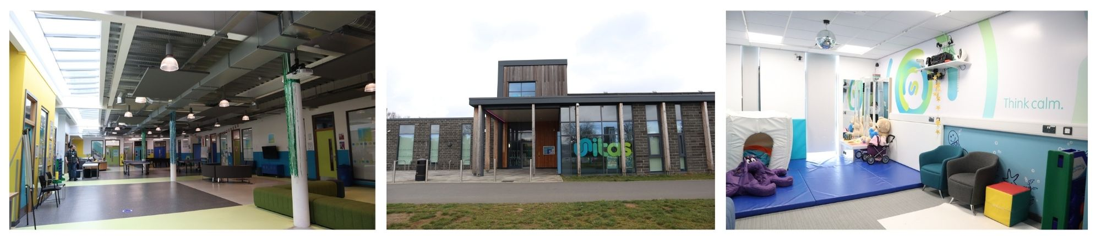

**Location: Unitas Youth Zone, Barnet**

**Suggested Time Commitment: 1 session per week (although there is flexibility in this)**

**VOLUNTEER INCLUSION YOUTH WORKER**

Our Volunteer Inclusion Youth Workers help us deliver specialist sessions that provide young people with additional needs/disabilities the opportunity to engage with their peers in a range of dynamic and engaging activities. These sessions provide a supportive & safe environment in which young people with additional support needs can build their confidence and their families or guardians can connect. The sessions promote their independence & explore/develop their skills, interests, and aspirations.

**ABOUT THE ROLE**



* Enjoys meeting and engaging with people from a wide range of backgrounds
* Is empathetic to the needs of young people with additional support needs
* Shares the same values as Unitas
* Is a strong communicator with the ability to (or the willingness to learn to) adapt their styles of communication
* Has the ability to adapt activities to suit the needs of the young person and can think on their feet
* Patient and calm under pressure
* Is committed to promoting inclusivity, accessibility, and making a positive impact on the lives of young people
* Is happy to undertake further training as necessary

**Please note that for this role you need to be at least 18 years of age and be prepared to undergo an enhanced DBS check.**

Please note that for this role you need to be at least 18 years of age and be prepared to undergo an enhanced DBS check.

**WHAT ARE THE BENEFITS TO YOU AND OUR YOUNG PEOPLE?**

**WHAT CAN YOU EXPECT TO BE DOING?**

* Supporting young people with additional support needs whilst they participate in different activities around the youth zone. This can include sports, arts, music, cooking and everything in between!
* Actively engaging with, spending time with and supporting young people with additional support needs and their families/guardians to foster a positive, supportive enviroment
* Encouraging young people to participate and enjoy their sessions
* Building positive relationships with young people and their families/guardians across the youth zone
* Working collaboratively with the Inclusion Coordinator and other members of staff to support the delivery and accessibility of sessions
* Acting as a positive role model for young people
* Promoting an inclusive culture where all young people are listened to, valued, and cared for, with particular reference to he wishes of young people with additional support needs

You will gain new skills and develop existing ones whilst making a significant contribution to the lives of the young people with additional support needs. You will become part of our team; our young people and their families/guardians will become a part of a positive support network. You will enhance your CV whilst also being there as a positive role model for many of our young people. The benefits really are endless!

**WE’RE LOOKING FOR SOMEONE WHO:**