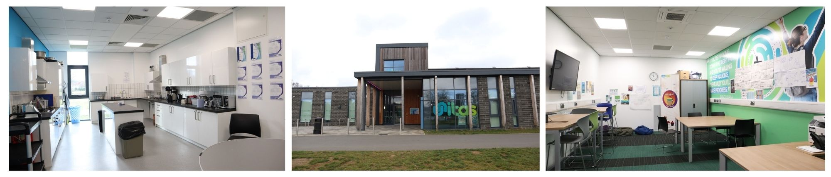

**Location: Unitas Youth Zone, Barnet**

**Suggested Time Commitment: 1 session per week (although there is flexibility in this)**

**VOLUNTEER LIFE SKILLS YOUTH WORKER**

**ABOUT THE ROLE**

Our Volunteer Life Skills Youth Workers help us to deliver sessions that bring young people together to learn independent living skills, primarily in the kitchen, but with a wider focus on general wellbeing. They support young people’s creativity and encourage them to explore new ideas so that they build their confidence, social skills and overall wellbeing.

You will gain new skills and develop existing ones whilst making a significant contribution to the lives of the young people. You will become part of our team and our young people will have a great time. You will enhance your CV whilst also being there as a positive role model to many of our young people. The benefits really are endless!

* Helping to deliver sessions that encourage young people develop their domestic skills including; budgeting, following recipes, hygiene, and using household appliances
* Encouraging young people to learn about the 3 pillars of health (physical, mental and nutrition) and inspire them to look after their own health and wellbeing.
* Assisting with projects to do with current themes i.e. waste, healthy eating etc.
* Sharing cultural values through food and cooking
* Encouraging young people to participate and enjoy their sessions
* Building positive relationships with young people across the youth zone
* Working collaboratively with the Health and Wellbeing Coordinator and other members of staff to support the delivery of sessions
* Supporting young people with additional needs
* Acting as a positive role model for young people
* Promoting an inclusive culture where all young people are listened to, valued, and cared for

**WHAT ARE THE BENEFITS TO YOU AND OUR YOUNG PEOPLE?**

**WE’RE LOOKING FOR SOMEONE WHO:**

* Enjoys meeting and engaging with people from a wide range of backgrounds
* Has a keen interest in food and an awareness of the role of food in different cultures
* Is patient and has the ability to able to confidently manage multiple tasks in a busy kitchen environment
* Shares the same values as Unitas
* Is committed to making a positive impact on the lives of young people   
  ------------------------------------------------------------------------------------------------------------------------------------------------------

**Please note that for this role you need to be at least 18 years of age and be prepared to undergo an enhanced DBS check.**

**WHAT CAN YOU EXPECT TO BE DOING?**