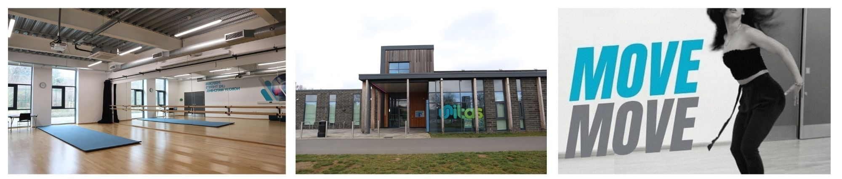

**Location: Unitas Youth Zone, Barnet)**

**Suggested Time Commitment: 1 session per week (although there is flexibility in this)**

**ABOUT THE ROLE**

**WE’RE LOOKING FOR SOMEONE WHO:**

**WHAT ARE THE BENEFITS TO YOU AND OUR YOUNG PEOPLE?**

* Helping to deliver sessions experimenting with different types of performance art such as; dance, drama and vocal groups
* Helping to organise and prepare for performances
* Encouraging young people to participate and enjoy their sessions
* Building positive relationships with young people across the youth zone
* Working collaboratively with the Arts Coordinator and other members of staff to support the delivery of sessions
* Supporting young people with additional needs
* Acting as a positive role model for young people
* Promoting an inclusive culture where all young people are listened to, valued, and cared for

You will gain new skills and develop existing ones whilst making a significant contribution to the lives of the young people. You will become part of our team and our young people will have a great time. You will enhance your CV whilst also being there as a positive role model to many of our young people. The benefits really are endless!

* Enjoys meeting and engaging with people from a wide range of backgrounds
* Is adaptable and happy to try new things
* Some experience in the performing arts would be great but if you don’t have any, an active interest and passion for performance will be more than enough!
* Shares the same values as Unitas
* Is committed to making a positive impact on the lives of young people   
  ------------------------------------------------------------------------------------------------------------------------------------------------------

**Please note that for this role you need to be at least 18 years of age and be prepared to undergo an enhanced DBS check.**

**WHAT CAN YOU EXPECT TO BE DOING?**

Our Volunteer Performing Arts Youth Workers help us to deliver sessions that bring young people together to celebrate creativity and performance. They support young people’s creative skills and encourage them to explore new ideas through performance to build their confidence, social skills and overall wellbeing.

**VOLUNTEER PERFORMING ARTS YOUTH WORKER**