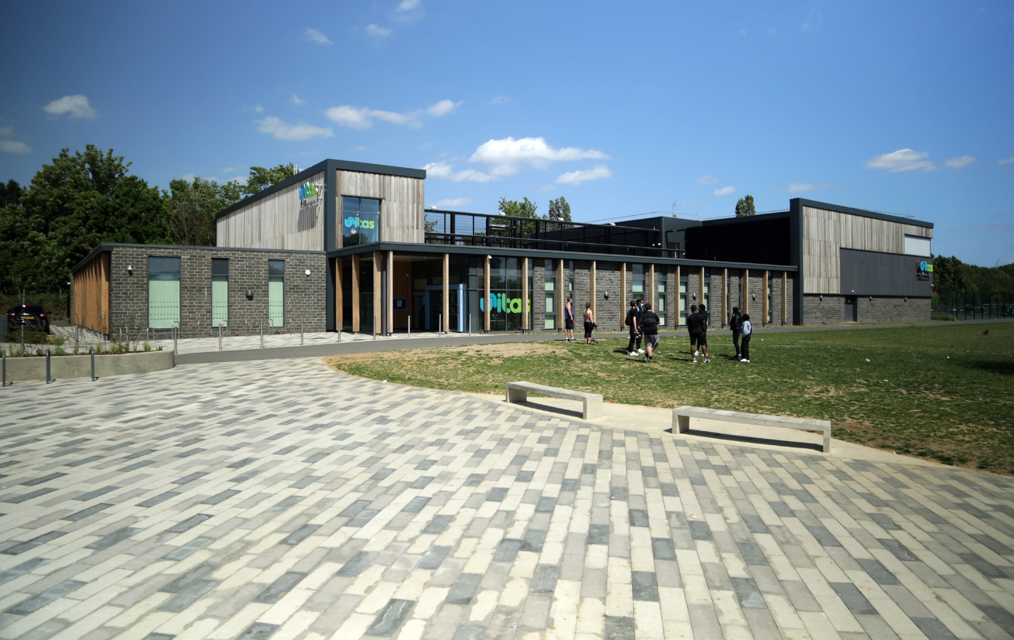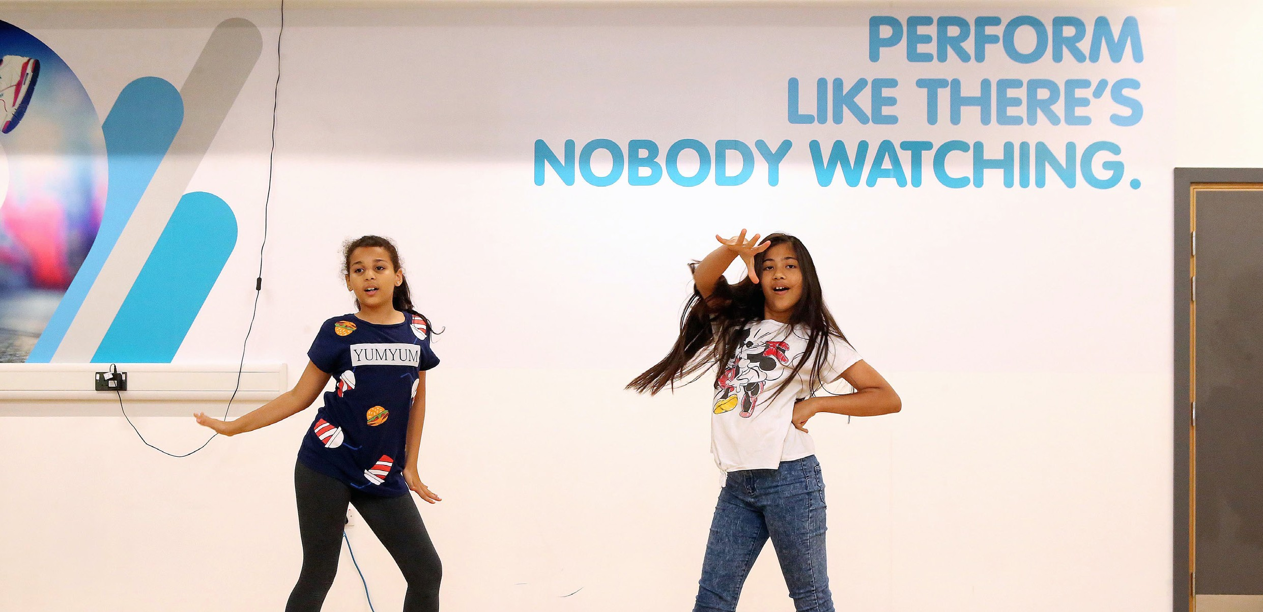

CANDIDATE INFORMATION PACK

CORPORATE PARTNERSHIP EXECUTIVE

UNITAS YOUTH ZONE

**Welcome from Micah Jorrisch, Director of Fundraising**Thank you for your interest in the role of Corporate Partnership Executive at Unitas Youth Zone.

Unitas is an incredibly exciting charity. Our cause is clear and compelling – **young people**. At Unitas, children and young adults unlock their potential, helping them to thrive as happy, confident, and successful adults.

We provide a safe, caring and encouraging space where young people, often from disadvantaged backgrounds, can connect with new friends and feel a sense of belonging.

During every visit, young people receive tailored support and mentoring from incredible youth workers, enjoy a hot, nutritious meal and access dozens of fun, enriching activities. Through all of this and more, Unitas helps young people build their sense of self-worth, resilience and ambition.

We are the largest provider of youth work in North London and were awarded “Charity of the Year” for 2025 by The Barnet Group and are one of The Mayor of Barnet’s chosen charities during his term.

The buzz when 150 young people are in Unitas really cannot be described on paper. It must be experienced. Of course, you should check out our website and social media channels to get a flavour of what we do. But as part of the application process, we will get you to visit to not just see but *feel* for yourself what we are about.

Unitas is a friendly, energizing and informal place to work. We take our work seriously but equally value having fun, enjoying achieving together, and supporting one another. The impact of our work is felt literally every single day. One of Unitas’ greatest strengths is the ability to bring our work to life for our donors through tours and visits to our building.

We are a local, independent charity but with the support of a national network, OnSide, meaning that we can access resources that many other local organisations cannot. We are led by a fantastic Board Chair, Stuart Levy and a capable Board of Trustees, who really understand the need to support fundraising and get stuck in to help.

An exciting opportunity has been created at Unitas Youth Zone for an ambitious fundraiser eager to share our story and secure funds and ‘gifts in kind’ from corporate donors. Working alongside myself, and as part of a small, supportive team, you will make a significant contribution to securing a legacy for thousands of local young people through the generation of new income.

Experience is great, but what we are really after is someone with strong integrity, a passion for serving young people, with an entrepreneurial spirit who will fearlessly engage the Unitas community to generate more funding for our critical mission. If you are that type of person, we want to hear from you!

We are a diverse organisation and we especially welcome applicants who can contribute to that diversity – candidates of colour, disabled candidates, candidates who have lived experience or are care-experienced etc. Of course, though, most of all, we want and will only hire the best.

Please visit our website for more information on the role or to complete an application [www.unitasyouthzone.org/work-with-us/join-our-team/vacancies/](http://www.unitasyouthzone.org/work-with-us/join-our-team/vacancies/) alternatively you can e-mail [recruitment@unitasyouthzone.org](mailto:recruitment@unitasyouthzone.org)

Best wishes,

Micah Jorrisch

ROLE PROFILE

POST:

Corporate Partnership Executive

REMUNERATION AND BENEFITS PACKAGE:

£33,000 - £37,000 per annum, or pro rata; automatic enrolment 3% (employer)/5% (employee) defined contribution pension; 33 days holiday inclusive of bank holidays, or pro rata; access to OnSide Talent Academy and ongoing professional development.

We have enhanced maternity, paternity and adoption leave after you have been with us for two years. We have a miscarriage/neo-natal death policy. We provide one “wellbeing day” a year as paid leave. Staff can use our fully-equipped gym while we are closed to young people. There is free parking onsite and when our café is open, you can purchase a meal for £1.

LOCATION:

Unitas Youth Zone: 76 Montrose Avenue, Burnt Oak, HA8 0DP

Some hybrid working is supported (up to 2 days a week from home) and you will be expected to be out meeting donors and prospects regularly

REPORTING TO:

Director of Fundraising

CONTRACT:

Permanent. We are open to either 1.0 FTE or 0.8 FTE contracts (flexibility required including occasional evenings and weekend events). Hours worked are generally flexible and certainly you are not tied to “9-5”.

OTHER INFORMATION:

Unitas is fully wheelchair-accessible.

THE ROLE

An exciting opportunity has been created for an ambitious fundraiser eager to share our story and secure funds and other support from corporate donors. Working alongside our experienced Director of Fundraising, and as part of a small, supportive team, you will make a significant contribution to securing a legacy for thousands of local young people through the generation of new income and other valuable resources.

Experience is great, but what we are really after is someone with strong integrity, a passion for serving young people, with an entrepreneurial spirit who will fearlessly engage the Unitas community to generate more support for our critical mission. If you are that type of person, we want to hear from you!

You will have responsibility for creating and executing strategies to develop significant corporate income and ‘in-kind’ support by leveraging our existing strong networks, creating a business development strategy and networking in the community. At the same time, you will support the Director of Fundraising and CEO by effectively stewarding existing corporate partners, ensuring that we continue growing strong relationships and sustained revenue.

You will get to work with a wide range of corporate partners from large corporations like ASOS and Burberry, to small local businesses. We will provide ample support and coaching to ensure you are equipped with the tools to be successful.

While securing new funding is crucial, you will also strategically leverage the skills, networks, and other tangible resources of our corporate partners to upgrade our facility, improve the quality of our activities, and generate more awareness about Unitas throughout our community.

You will be part of a ambitious, capable fundraising team that is eager to grow our fundraising and have fun while we are doing it.

CONTEXT OF THE ROLE

Barnet is London’s second-most populous borough with almost

400,000 residents, of whom almost a quarter are under 18.

Burnt Oak and Colindale, where Unitas is located, are the

most deprived areas of the borough, with child poverty rates

of 38% and 37% respectively. Unitas’ universal access, six-day-week provision is unique to the area and over 700 young people access our spaces every week. We currently do not receive any substantive government funding and fundraising is

required to cover 90% of our operating costs.

KEY RESPONSIBILITIES

* In collaboration with the Director of Fundraising, you will set targets to secure new corporate supporters for Unitas
* Work with key volunteers, OnSide staff, and Unitas colleagues to proactively network to identify/develop new leads and opportunities for funding and partnerships
* Build Unitas’ corporate ‘Case for Support’ that includes compelling reasons and clear benefits for companies to get involved with Unitas
* Develop supporter stewardship strategies to build and maintain strong relationships with corporate partners
* Work closely with the Marketing and Communications team to develop compelling content to engage with prospective and existing corporate donors
* Ensure strong corporate participation with our flagship fundraising efforts including our Uniquely Unitas Dinner and London Without Limits crowdfunding campaign
* Produce high-quality proposals and make presentations and/or face-to-face asks to a range of audience
* Create compelling corporate volunteerism opportunities that bring in new supporters and act to steward existing donors.
* Deliver cultivation and stewardship events as needed

ALL COLLEAGUES ARE EXPECTED TO

* Be a role model for young people, present a positive ‘can-do’ attitude and take personal responsibility for your actions.
* Work within our values and contribute positively to the work culture.
* Work within the performance framework of Unitas Youth Zone and OnSide and commit to a culture of continuous performance.
* Represent and promote Unitas in all dealings internally and with external partners.
* Comply with all policies, procedures, and codes of conduct, with particular reference to safeguarding, health & safety, and equality and diversity.
* To be willing to step in and step up, and not see the above set of duties and responsibilities as exhaustive.

WHAT SUCCESS WILL LOOK LIKE

* There will be an ever-strengthening pipeline of potential corporate donors
* You will have a full calendar of events and meetings outside of the office networking with prospective and current donors
* An exciting Case for Support and communications plan that generates new interest and increases engagement of current supporters
* Existing corporate supporters will feel engaged with Unitas and continue to pledge financial support
* Our corporate supporters feel inspired to not only give but also to open further doors to new prospects
* Corporate partners are leveraging their non-financial assets to improve our services, support our people and upgrade our facilities
* Our Sales Force CRM database will be updated with easy to access reports allowing us to track ongoing success
* You are consistently accessing the OnSide network for support and best practice in relation to your role and professional development

UNITAS YOUTH ZONE

North London’s Youth Zone, named “Unitas” by local young people, opened in summer 2019.

At Unitas, children and young adults unlock their potential, helping them to thrive as happy, confident, and successful adults.

We provide a safe, caring and encouraging space where young people, often from disadvantaged backgrounds, can connect with new friends and feel a real sense of belonging.

During every visit, young people receive tailored support and mentoring from incredible youth workers, enjoy a hot, nutritious meal and access dozens of fun, enriching activities. Through all of this, and more, Unitas helps young people build their sense of self-worth, resilience and ambition.

Since opening we’ve supported over 12,000 young people from a diverse range of backgrounds to thrive.

We are currently open six days a week (35 hours), with an aspiration to be open seven days a week (43 hours), while schools are closed - that’s evenings and weekends, plus all through the school holidays. We offer a safe and active space for young people to flourish in their leisure time, where their interests can be nurtured, and they can grow as individuals. Averaging 750 visits per week, this is a charity that the whole community can be proud of, and you can be part of that journey.

Entry is just 50p each time and annual membership costs

£5 which gives a young person access to over 20 activities every time they visit.

Unitas Youth Zone is a proven model of youth work that is aligned to community needs and supported by cross-sector funding. We give 8–19-year-olds, (and up to 25 for young people with additional needs) affordable access to a broad range of sport, arts and employability services, designed to empower them to lead healthier, positive and more active lives – raising their aspirations for themselves and their community.

The facilities are second to none, delivering sporting, artistic, cultural and life skills activities each session. The outstanding quality of the facilities is a concrete demonstration of the belief that young people deserve the best.

ABOUT ONSIDE

Potential is everywhere. In every home on every street, from affluent suburbs to inner-city estates. The difference is that some young people get every opportunity to explore their potential. Others don’t.

It’s about opportunity.

Unitas is proudly part of the OnSide Network. OnSide is a national charity that believes all young people should have the opportunity to discover their passion and their purpose. To find out what they’ve got and where it could take them.

OnSide funds and build state-of-the-art, multimillion- pound Youth Zones in the country’s most economically disadvantaged areas. They train the amazing people that run them. And they offer continuing support via the nationwide OnSide Network of 14 Youth Zones (and growing), where colleagues can learn and grow, share their stories, and celebrate their success together.

This is passionate, properly funded youth provision, with no ifs or buts. A unique partnership between young people and their community, local authorities and private business leadership, and a growing movement of supporters who believe that how we treat the next generation defines who we are as a society.

Because when we really invest in young people, we all benefit – from who they are now, everything they might become and achieve, and everyone they might touch and inspire. All they need is the chance to shine – an environment where they can be their best selves – and you just watch them go.

It’s about opportunity.

# PERSON SPECIFICATION

Applicants will be expected to demonstrate the experience, skills, abilities and attributes listed.

|  |  |
| --- | --- |
| SELECTION CRITERIA | REQUIREMENT |
| **KNOWLEDGE AND EXPERIENCE** |  |
| Experience of generating income for a company or nonprofit organization through a variety of methods (i.e. face-face sales, events, campaigns) | Essential |
| Experience of meeting financial targets for new business and/or customer stewardship | Essential |
| Experience of developing and managing a pipeline of potential supporters/donors/customers | Essential |
| Knowledge of the non-profit sector and experience working professionally or voluntarily in a non-profit setting | Desirable |
| Experience in securing 5-figure + income from corporate partners for a nonprofit organization | Desirable |
| **SKILLS** |  |
| Ability to confidently make face-to-face approaches for funding from corporate partners | Essential |
| Strong interpersonal and networking skills, to build positive, personal and organisational relationships and convey the Youth Zone’s work with confidence and credibility. | Essential |
| Strong organisational skills, with a structured and methodical approach to work, a clear focus on results, and an ability to work to multiple deadlines | Essential |
| Ability to think conceptually and creatively, to develop high quality fundraising materials and proposals for supporters | Essential |
| IT literate and confident user of databases and Microsoft Office tools | Essential |
| Previous experience using Salesforce | Desirable |
| **KNOWLEDGE** |  |
| Knowledge and awareness of issues affecting young people | Desirable |
| Understanding and knowledge of the Barnet/North London community | Desirable |
| **SPECIAL REQUIREMENTS** |  |
| A willingness to work unsociable hours when required | Essential |
| Demonstrable commitment to the goals and drivers behind the Youth Zone/OnSide | Essential |
| Enthusiasm and ability to contribute to the successful development of the Youth Zone | Essential |
| Enhanced DBS clearance and commitment to Safeguarding children | Essential |
| Clean UK driving license and use of a car when necessary | Desirable |

GENERAL INFORMATION

There will be a requirement to work outside the normal 9 to 5, Monday to Friday, working week, including both evenings and weekends in order to meet the needs of donors and prospects. This will mean working flexibly across the week, to suit the needs of both the role and the individual. Unitas seeks a flexible and family-friendly workplace and the needs of your life outside of work will of course be considered in relation to your work hours.

APPLICATION PROCESS

Please also complete our Equal Opportunities form, [available here,](https://www.surveymonkey.co.uk/r/CYH8PMY?CPDept=SeniorAppts&Con=233) which will enable us to continue our v

In the first instance, please complete a Unitas application form & send a CV and a short document that answers the following three questions:

1. ***Why do you want to work for Unitas?***
2. ***And why does this role appeal to you?***
3. ***How would your skills and experience enable you to be a brilliant Corporate Partnership Executive? (Please refer to the JD and person specification above)***.

In accordance with our Child Protection and Safeguarding procedures, this position requires an enhanced DBS check. The strength of the OnSide community comes from the diversity of the people within our vibrant network. We are proud that our Youth Zone team reflects the communities we serve, and we value people working together from a range of different backgrounds and with different experiences, all with a shared passion for boosting the aspirations of young people in Barnet. Diversity brings innovation, fresh ideas, and creativity, and we actively strive to create a culture that is truly inclusive and fair for all and where everyone in the team can be themselves and thrive.

CASE STUDY: HANNAH AND FAWZIYA’S STORY

We firmly believe that Youth Zones are places that change lives, but don't take our word for it - our young people tell us this all the time!

Two examples are best friends Hannah (17) and Fawziya (16). Hannah and Fawziya didn't know each other before they came to Unitas. They both attended a session in the Music Room and it is this session that they credit with being the start of their friendship.

Both avid film and media enthusiasts, they told us that "the Media Room has changed our lives" and when asked about how Unitas has impacted their lives outside of the Youth Zone, Fawziya said, "I found my passion for film at Unitas. I wouldn't have applied for the BRIT School and be studying film and media there if I hadn't been coming here."

Similarly, Hannah told us that Unitas showed her that she could make a career out of something that previously had just been an interest. The facilities the Youth Zone offers are vital to both girls. "The big impact is that there are creative spaces here … I think it's really important to have these creative spaces where we can nurture the talents that we have ... I think you don't really realise that until you enter a place like this where you can really open your eyes."

Hannah now attends the London Screen Academy in Islington, and Fawziya attends the BRIT School in Croydon. Fawziya continues to come to Unitas after college because "I didn't have anything to do before coming here ... it's engaging here and the engagement is what pulls people in, and it's what makes you want to do things."

They continue to create new projects such as 'CHATBOX', a series of video blogs where they discussed issues that affected them and their peers and Fawziya was even selected as one of the winners of last year's Show and Tell photography competition. Selected from over 22,000 submissions, her submission was featured on over a hundred billboards around the UK! Meanwhile, Hannah has put her film skills into practice in Unitas' Media Squad, doing all the videography for our recent amateur boxing events.

When asked about how Unitas' youth workers support them, Fawziya said "to have someone who believes in you is one thing but to have someone to tell you that you are capable of more than you think and are yet to discover is really important." Hannah echoed these sentiments "The youth workers really push us to become what we can truly be and reach our full potential."

We asked them to sum up Unitas. "It’s like a second home. It doesn't feel like you come here into another school environment, it feels like I'm going home, just with more people! ... it's an environment with a different meaning and a different purpose. Even though it's got this incredibly homely vibe, it's still somewhere we are pushed to be our best, and

to do whatever we think is possible.



