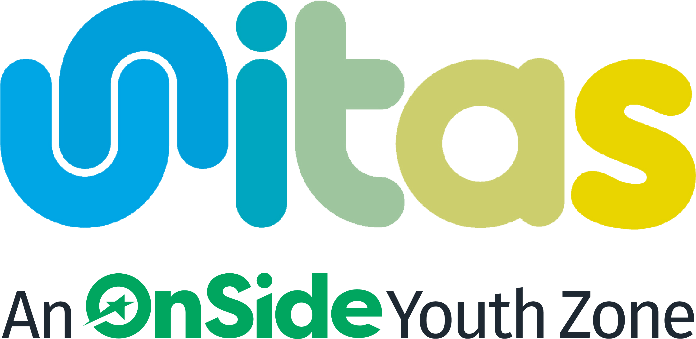


APPLICATION FORM
Unitas is proud to be an equal opportunity employer. All applicants will be considered for employment without attention to disability, gender reassignment, marriage and civil partnership, pregnancy and maternity, race, religion or belief, sex, or sexual orientation.

Please be aware that as Unitas Youth Zone seeks to serve young people outside of school hours we therefore require all staff to be able to work flexibly over the course of a 6-day week, with the core sessional hours being of weekday evenings from 3:45pm onwards and weekends.
Please complete this form electronically. If you are unable to complete electronically, please use black ink.
Shift Time | Available (Y/N)
Tuesday 15:35pm - 21:15pm
Saturday 09:45pm - 14:15pm

Saturday evenings (paid at a premium of £15.42 per hour)

PART A: PERSONAL INFORMATION
Position applied for | Sessional Youth Worker

Surname (block capitals)
Preferred first name
Names in full (block capitals)
Address (including postcode)
Phone (for us to contact you)
Email
Are you eligible to work in the UK?
National Insurance number

PART B: PERSONAL PROFILE
Please summarise in no more than 120 words, why you believe you are suited to the roles that you have applied for. (You will be able to expand on your experience, competencies and qualifications in Parts C, D and E.)

PART C: EDUCATION & TRAINING
Based on the Person Specification, please list education, training, any relevant professional qualifications, and membership of professional organisations below.

Date | Subject | Educational establishment | Qualification/Grade
Please continue an additional sheet if necessary (or extend table)

PART D: EMPLOYMENT HISTORY
Starting with your current/most recent employment.

Dates  Start & Finish | Employer  Name & Address | Job Title, Main Responsibilities,  Major Achievements | Final Salary, Reason for Leaving
Please continue an additional sheet if necessary (or extend table)

PART E: INFORMATION TO SUPPORT YOUR APPLICATION

Looking at the role profile, please explain how your skills, knowledge and experience meet the requirements of the job role. Additionally, please add any further relevant information to support your application.

PART F: REFERENCES
Please give the names and addresses of two people whom we may contact for a reference. Please note that OnSide reserves the right to contact any of your former employers. References given should cover the last 5 years of your employment. The first of your references must be your present employer. If you are unemployed, this should be your last employer, or if this is your first job, your headteacher or college tutor. Personal references (e.g., from your GP or friends) are not acceptable.
 | CURRENT EMPLOYER | SECOND REFERENCE
Name
Job title
Organisation
Address
Phone
Email

How do you know your second referee?
Can we take up your references before interview?

PART G: GENERAL

REHABILITATION OF OFFENDERS ACT 1974
Owing to the nature of the work, the youthwork profession is exempt from the previous provisions of the above Act. Therefore, applicants are not entitled to withhold information about convictions which for other purposes are ‘spent’ under the provisions of the Act. OnSide has the facility to check for convictions.
Have you at any time been convicted of a criminal offence?
If ‘Yes’, please give details in strict confidence
How did you find out about this position?
Do you hold a current full driving licence?
How long have you held this licence?
Please give details of current endorsements or driving convictions:
If appointed, how soon could you join us?

PART H: DECLARATION

I confirm the information given on this form is correct and complete. I acknowledge that misleading statements may be grounds for cancelling any agreements made. I understand that an Enhanced Disclosure will be sought in the event of a successful application.
Signed: |  | Date:

Please return this form by email to our recruitment inbox at recruitment@unitasyouthzone.org , with the subject heading of the role you are applying for.

For information regarding how Unitas Youth Zone processes your data, please click here: https://www.unitasyouthzone.org/privacy-policy/

